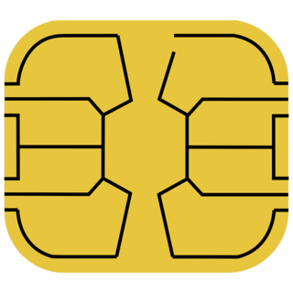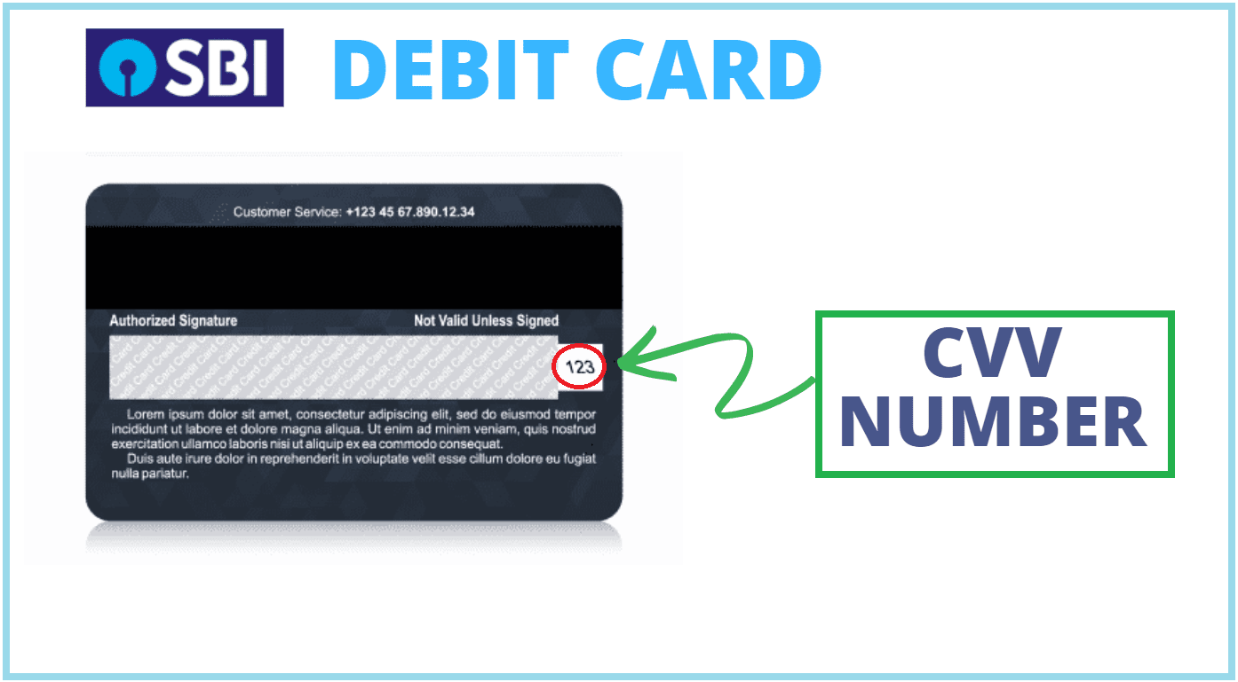

SACHIN **02\26**

**11/25**

6754 4563 5764 6547

**DEBIT CARD**

**VISA**

Thank you for accepting this card . we will make sure this card help you so much and this may for you beneficial

544

544

SBISBI

Lol